Offline Fastmap Instructions
1.- Unzip the content of the fastmap zip file.
My fastmap is under C:\FASTMAP
Under C:\Fastmap\lib create a new folder called jre
2.- Install the old java version select custom install and set the install folder to C:\Fastmap\lib\jre
3.- Launch Fastmap, by double clicking on fastmap.cmd
4.- For this example refer to the JB.xls file
I have put this file in the input subdirectory of my C:\FASTMAP
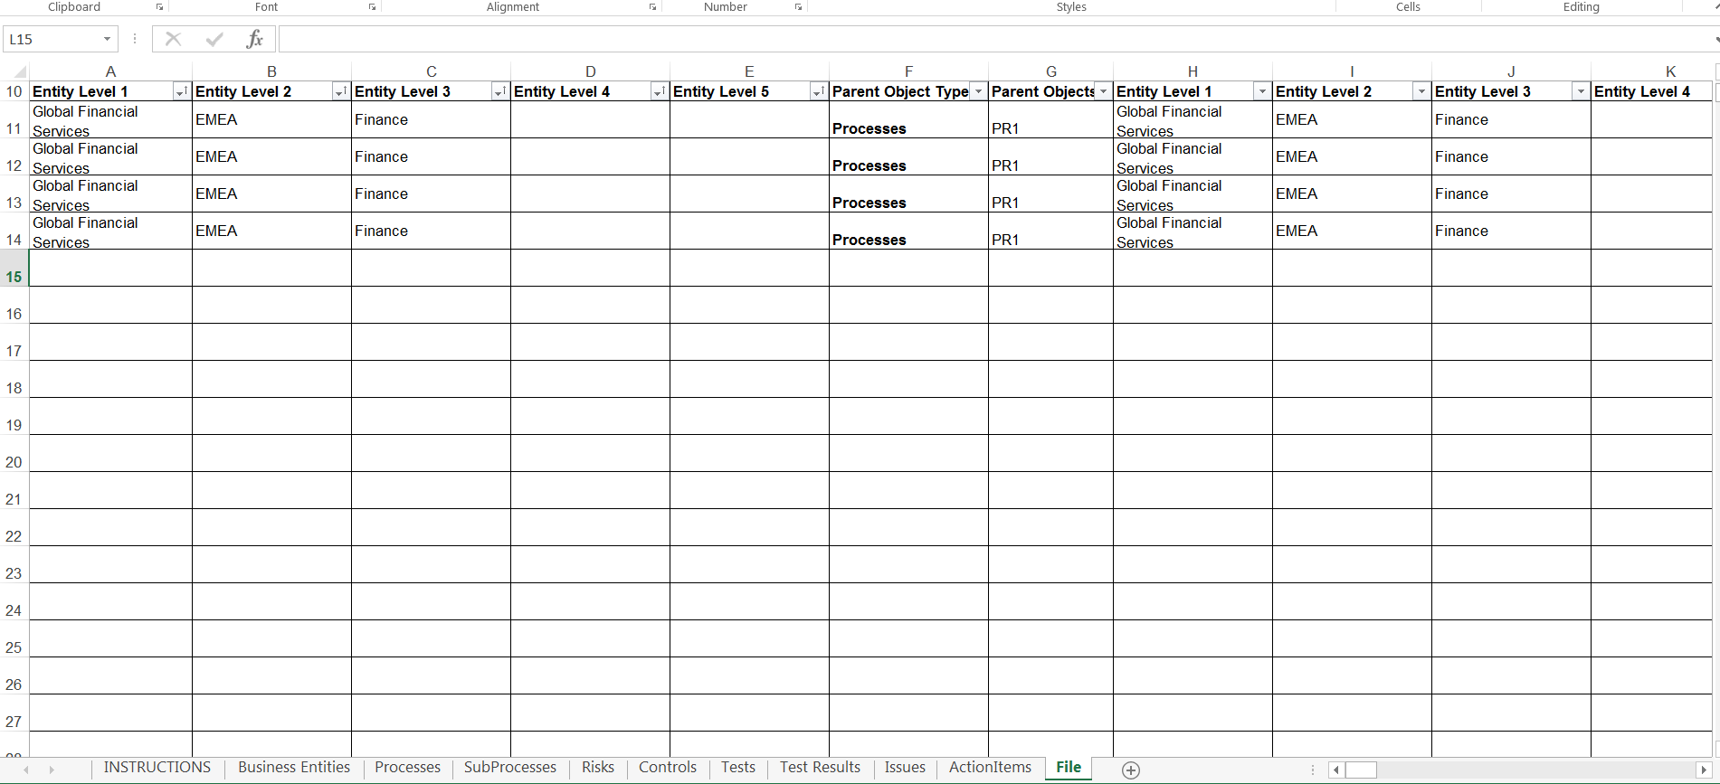
What I’. doing here is adding 2 documents for a process (PR1) that exists currently under Global Financial Services/EMEA/Finance hierarchy structure
The files that I want to attach I have put them under c:\data on my local hard drive
This is reflected here when I launch FASTMAP
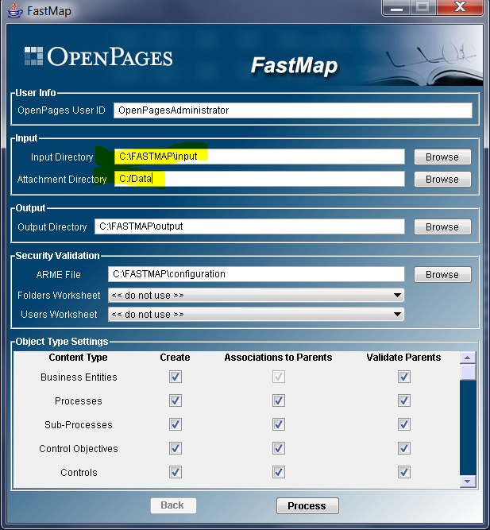
After I click process It will process the file and will create 3 entries in the \FASTMAP\output directory
I then copy these 2 files to the OP server
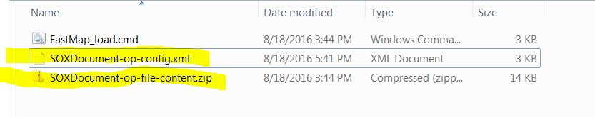

Where I can do an Objectmanager load
